**Practical No.02**

**Q.A) Simple Queries with MongoDB**

* **Queries and its Outputs given below:**

1. **Projection**

db.student.find({},{"Name":1,"_id":0})

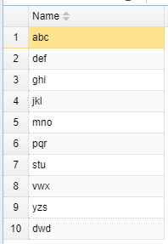

1. **Limit()**

db.student.find().limit(4)

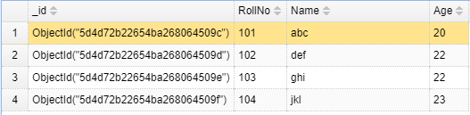

1. **Skip()**

db.student.find().skip(5)

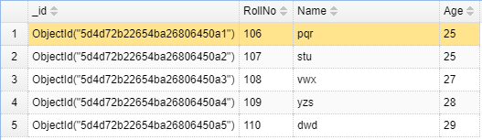

1. **Sort()**

db.student.find().sort({"Name":1})

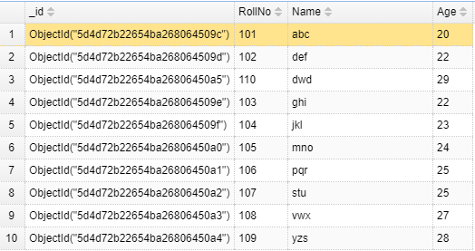

1. **Find all**

db.student.find()

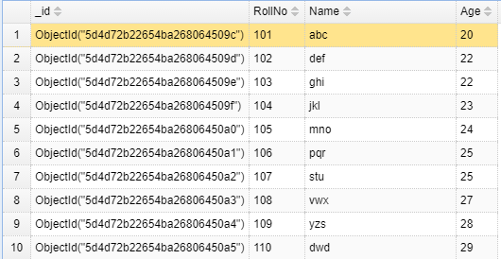

1. **Find with AND**

db.student.find({"Age":22,"RollNo":103})



1. **Find with OR**

db.student.find({$or: [{"Age":22},{"RollNo":103}]})

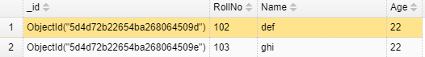

1. **Find Greater than**

db.student.find({"Age":{$gt:25}})

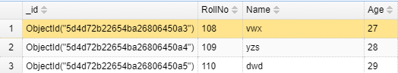

1. **Find Less than equal to**

db.student.find({"Age":{$lte:23}})

